Unit 3: EV3 Hardware, Software, Firmware Quiz
Name:__________________ Period:___ Date:______ Score:_____/28

1. What is the difference between hardware, software, and firmware? (3 pts)

2. Identify the three main parts of a microprocessor and describe the function of each. (6 pts)

3. Is EV3-G a machine language or higher level language? (2 pts)

4. If a robot had no firmware or software, what will it do? (2 pts).

5. Describe each block from the On-Brick palette: (5 pts)

- 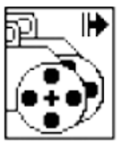 2. 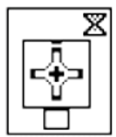 3. 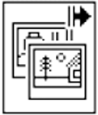 4. 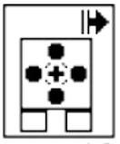 5. 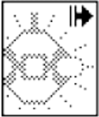

Block 1___________________________________________________________

Block 2___________________________________________________________

Block 3___________________________________________________________

Block 4___________________________________________________________

Block 5___________________________________________________________
- (4 pts) What is the difference between the EV3 Trainer program and the EV3-G Programming software? Should they ever be used at the same time? Why?

- (2 pts) What are “comments” in EV3-G and how should they be used?
- (2 pts) What are two ways to view a program in EV3-G which is larger than the programming window?
9 (2 pts) What are two ways to run a recently downloaded program on the EV3 brick?

